TKINTER TASK LIST APP

DATA STRUCTURE FOR STORING ONE TASK
- A task needs at least:
  - Description = "Buy groceries"
  - completed = False
- A dictionary is easy to understand and easy to access:
  - task["description"]
  - task["completed"]
- Compared to a list, we would have to:
  - task[0]
  - task[1]
- So one task will be:

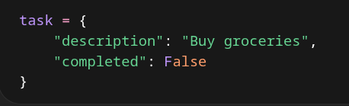

DATA STRUCTURE FOR STORING MULTIPLE TASKS
- We will need to store a collection of tasks
- The best and simplest choice is a list, and each task dictionary goes in the list
- A list is a good choice because lists have an order, and they're easy to display from top to bottom

